ISUBid Supplier Registration Guide

Preliminary Info Tab
Enter preliminary information about your company:
Click

Terms Tab
Read and accept the Terms and Conditions for using the software:
Click

Company Info Tab
Enter Company Information, Company Address and your User Information:
Tip: Your password must contain a minimum of 8 characters consisting of at least 1 number, 1 letter and 1 special character @#$%!&*^_-+={}()|\[]:;'<>,.?/~
Click

At this point you will be asked to verify your email address. Click in the pop-up window.

You will receive an email from Iowa State Procurement. Clicking on the link in the email will take you back to the Company Info tab, allowing you to complete your registration.

After clicking the link, you return to the Company Info Tab with the information you filled out.
Click

Addresses Tab
The address you entered on the Company Info tab is automatically included. Click to add more addresses if needed. The type of address is specified for each additional address:
- Bid/Quote Mailing
- Payment
- Purchase Order
- Emergency Contact

Click to add the address.

The new address will display on the Address Tab
Repeat the above steps to add additional addresses. Click when you are done adding addresses.

W-9 Tab
A substitute W-9 Tax Identification Form is generated using the information provided. Complete any remaining fields and check the four (4) certification statements at the bottom. Type your name and today’s date.
Click

Commodity Codes Tab
You must select at least one commodity. The commodities are listed in alphabetical order and grouped by categories. Scroll through the list and select all the commodities that apply to your company by clicking on the plus (+) sign next to the commodity category to open the group, then selecting the individual commodities that apply, or you can select the entire group. You can also use the search box to find a commodity. You will receive email notifications if a bid is issued in one of the commodities that you selected.
Click

Classifications Tab
Check any special business classifications that apply to your company; if none, then check "None Apply". You have the option of uploading supporting documentation for any of the special classifications. Supporting documents are not required however.
Click
You will also receive a notification email approving your special classification selection.

Review Tab
Review all the information entered for the registration. To make corrections, click "[edit]" on the section (located to the far right on the black bar for each section). Or you can use the tabs to go back to edit a section.
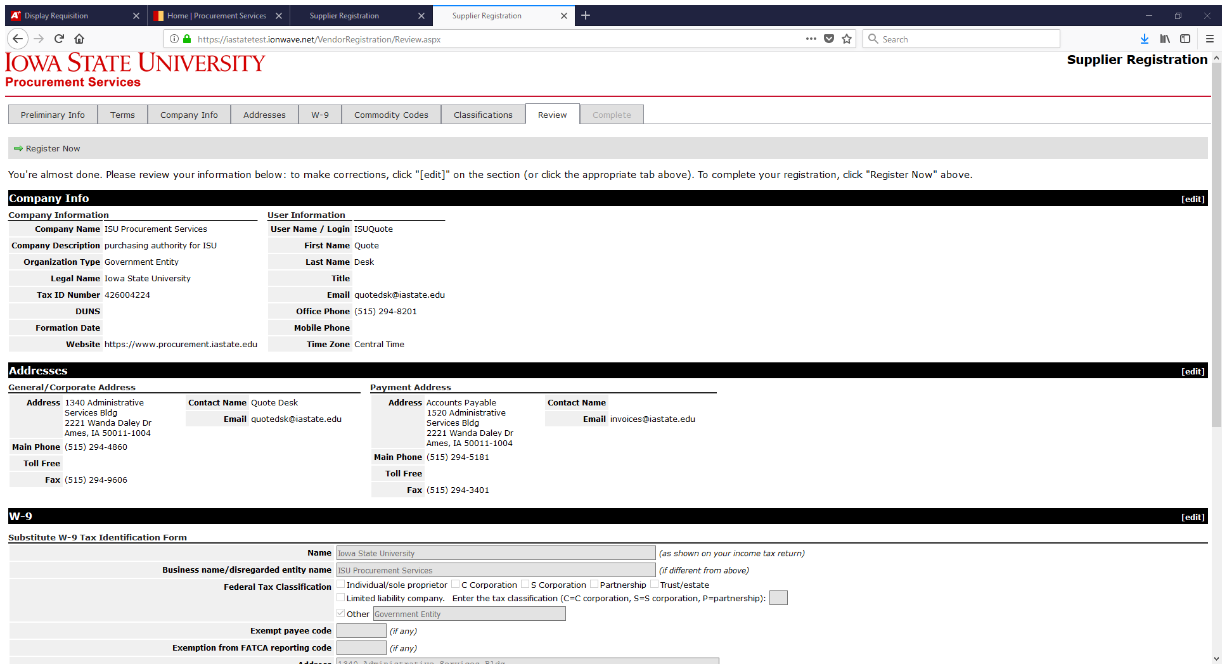
To complete your registration, click

Complete Tab
Confirmation of your registration.
You will also receive an email notification that your registration has been activated.

